# **ER to Relational Schema**

Before building the full logical schema, we must convert our ER diagram into the relational schema, by mapping the attributes from the primary key to the foreign key. The goals of the mapping are presented in the following statements. The first is to preserve all information that includes all the attributes. Second, we map the following ER diagram to maintain the constraints to the extent possible attributes. The third is to minimize the null values by applying the concept of natural forms. In this paper, we will mainly discuss the steps which we applied to implement the conversion of ER diagram into the logical schema.

# **Mapping of Regular Entity Types**

Figure - Mapping of Regular Entity Types

In this step, we map the regular entity types for each regular entity and choose one of the key attributes as the primary key. If the chosen key of the entity is composite, the set of simple attributes that form it will be together from the primary key of the following relation. The following results are presented in Figure 1.

# **Mapping of Weak Entity Types**

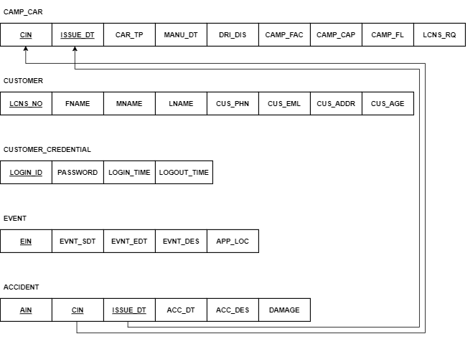

Figure - Mapping of Weak Entity Types

In the second step, which is the mapping of weak entity types, we must map each weak entity in the ER schema with the owner entity to create a relation that includes all simple attributes of the weak entity. Also, we must include as foreign key attributes of relation the primary key attributes of the relation that correspond to the owner entity. The primary key of the relation is the combination of the primary key of the owner and the partial key of the weak entity type. A weak entity in our database is the accident entity, which owns a camping car. The results of mapping the following entity are presented in Figure 2.

# **Mapping of Binary 1: 1 Relation Types**

Figure - Mapping of Binary 1:1 Relation Types

In this step, we must map 1 to 1 relationship entities. For each binary 1 to 1 relationship type in the ER schema, we must identify the relations that correspond to the entity types participating in the following relations There are three possible approaches to resolve these types of relations. First, we can choose one of the relations and include a foreign key in the entity from the primary key of an opposite entity. It is better to choose an entity type with total participation in the role of the entity. The second is the merged relation option. AN alternate mapping of a 1-to-1 relationship type is possible by merging the two entity types of the relationship into a single relationship. This may be an approach when both participations are total. The last is cross-reference or relationship relation. The third alternative is to set up a third relationship for cross-referencing the primary keys of the two relations and representing the entity types. A 1-to-1 relationship in our database is the relationship between customer and customer credential entity. To resolve the following relation, we added the foreign key to the customer table which is from the primary key of the customer credential primary key, LOGIN_ID. The results are presented in Figure 3.

# **Mapping of Binary 1: N Relation Types**

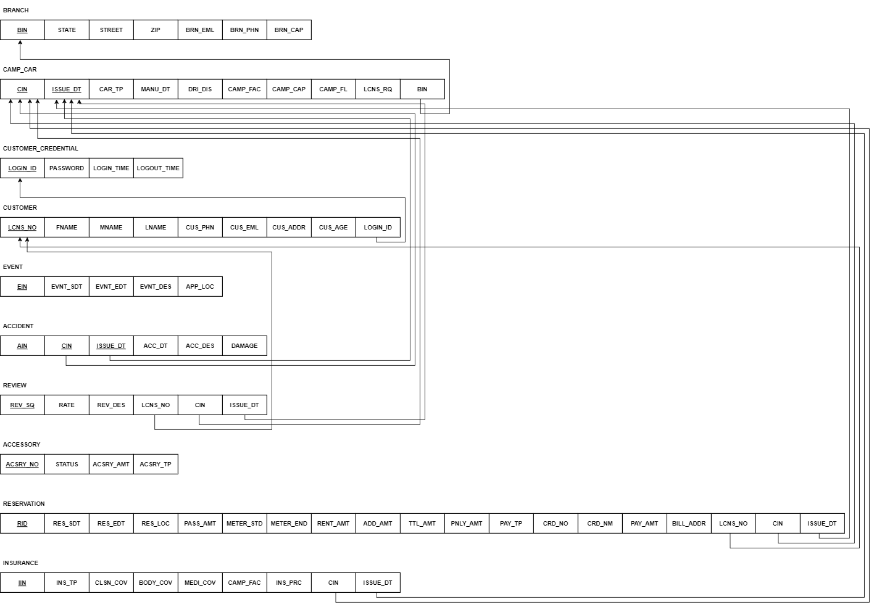

Figure - Mapping of Binary 1: N Relationship Types

In this step, we must map 1 to numerous relation types. For each regular binary 1 to numerous relationship types, identify the relationships that represent the participating entity type on numerous sides of the relationship type. To implement the following relationship, we must include as a foreign key in the 1-side entity the primary key of the relation numerous-side entity that represents the other entity type participating in the following relationship. We can include any simple attributes of the 1 to numerous relationship types as retributes of the 1-side entity. By applying the following method to implement 1 to numerous relations in our database, we can get the result which is presented in Figure 4.

# **Mapping of Binary M: N Relation Types**

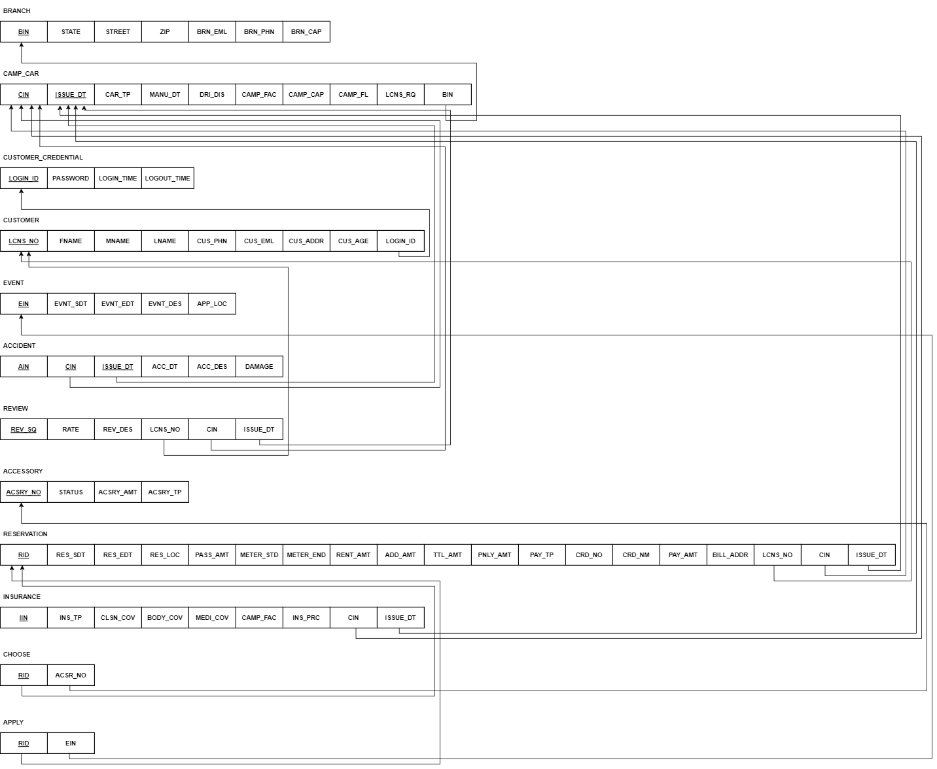

Figure - Mapping of Binary M: N Relationship Types

In this step, we must map the entities that have the relation of numerous-to-numerous relationships. For each regular binary numerous to numerous relationship types, we must create a new relation to representing the following relationship. This is a relationship. This includes as foreign key attributes in one entity the primary keys of the relations that represent the participating entity types; their combinations will form the primary key of the entity. Also, this includes any simple attributes of the numerous-to-numerous relation type as attributes of S. In our database, reservation, accessory, and reservation and event entity generate the numerous-to-numerous relationships. By applying the following method to implement numerous relationships, we can get the results presented in Figure 5.

# **Mapping of Multivalued Attributes & N-array Relation Types**

These steps are needed to map the ER diagram to a relational schema. However, because our database does not contain the following relations, such as multivalued attributes and N-array relation types, this mapping method is skipped. In short, Figure 5 in section 5 is the result of the conversion from ER diagram to a relational schema.